**MiniKube Installation**

Install using Docker Desktop Settings 🡪 Kubernetes 🡪 Check Enable Kubernetes 🡪 Apply

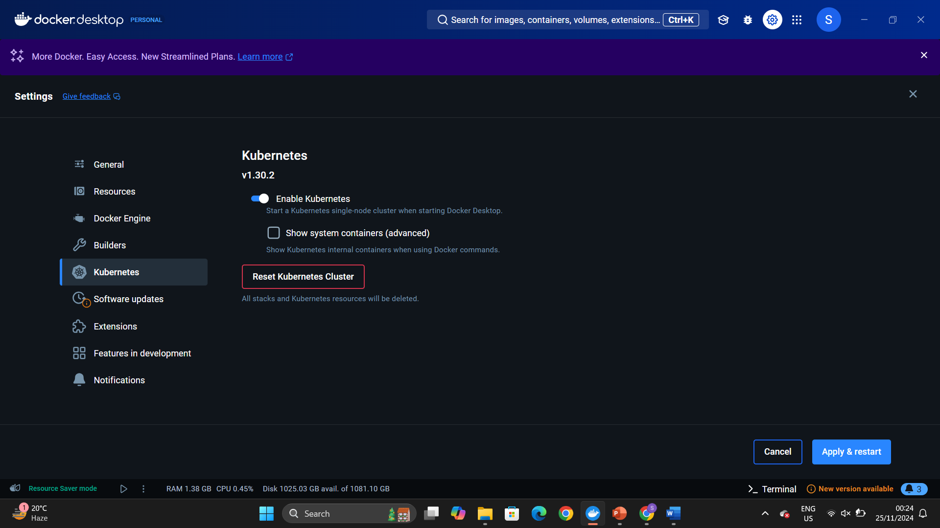

Search for minikube installation

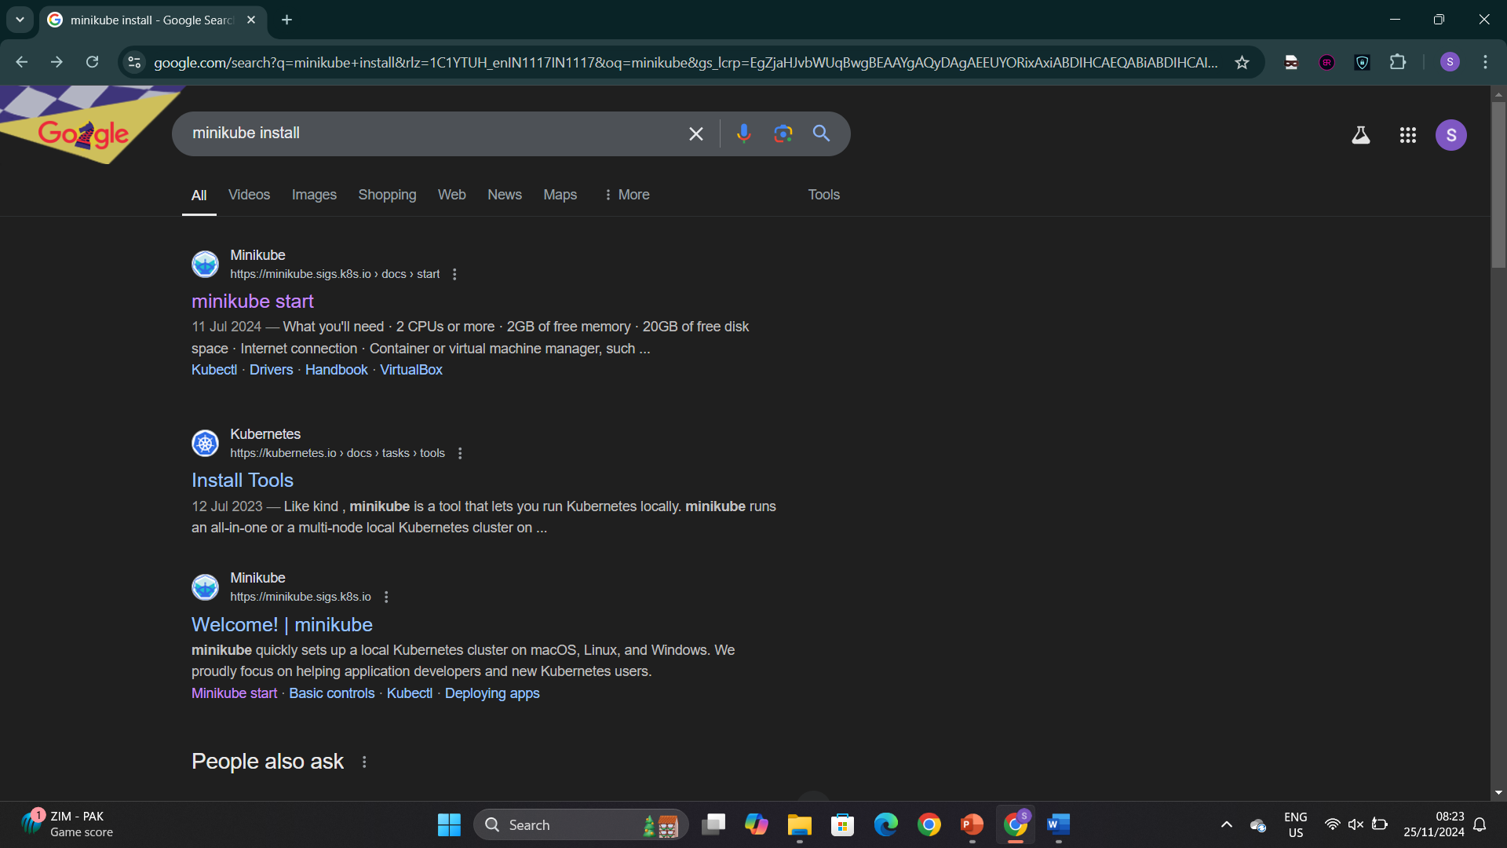

Download the required minikube installer for the windows platform

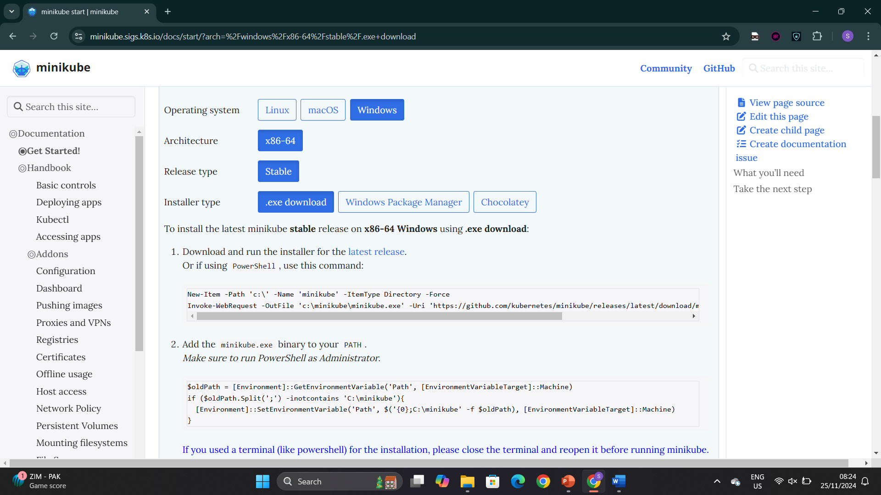

Install minikube from powershell

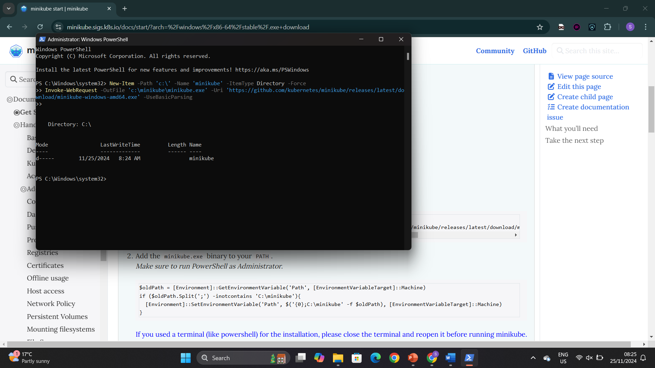

Set the path from powershell

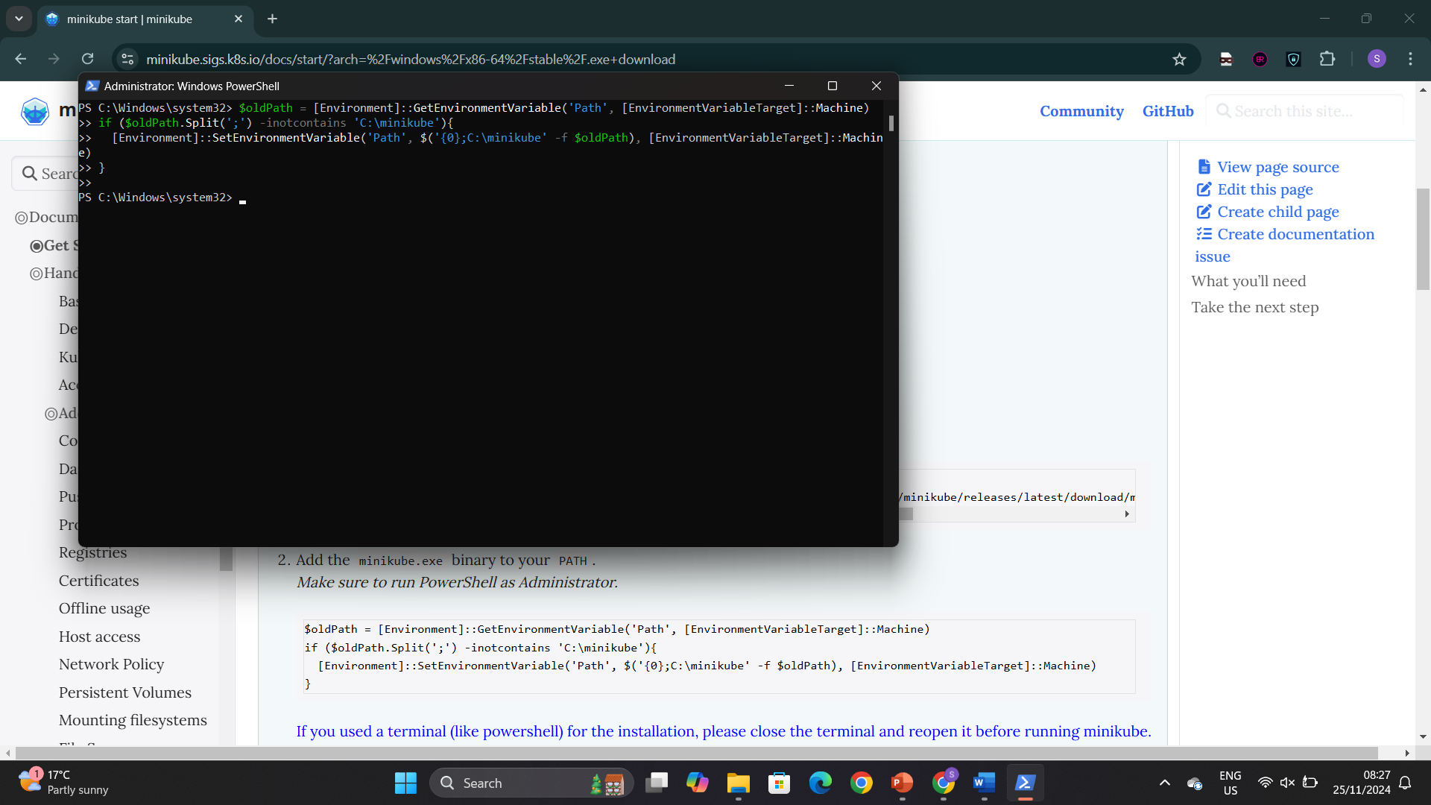

Start your cluster by running the following command in powershell > minikube start

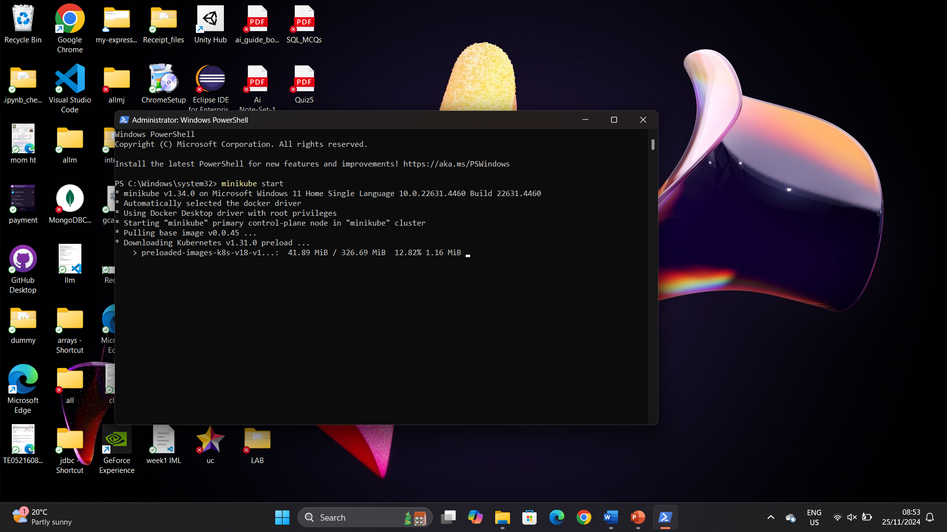

To check which ip address minikube is running type > minikube ip

Then type kubectl get po –A to see the nodes

